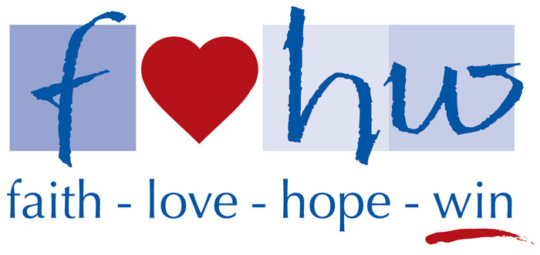
www.flhw.org
2018 Sponsor Registration Form

Company Name ________________________________________________
Description of Business __________________________________________
Address _______________________________________________________
_______________________________________________________
Contact Name __________________________________________________
Contact Telephone Number _______________________________________
Sponsorship Level (check one)
______ Double Eagle Sponsor ($5,000 minimum donation)
______ Eagle Sponsor ($2,500 minimum donation)
______ Birdie Sponsor ($1,000 minimum donation)
______ Par Sponsor ($500 minimum donation)
______ Friend of FLHW Donation (If you are unable to play and/or sponsor, but would still like to make a
donation, we appreciate your support.)

Please mail this form, along with your check payable to “FLHW”:

FLHW
15816 Ash St.
Overland Park, KS 66224

To allow time for construction of sponsorship materials, please have your
contribution delivered by August 28th.
Thank you for your generous support!!
** FLHW is a 501(c)3 non-governmental, non-profit corporation, recognized by the IRS as a tax exempt public foundation. Donations are tax deductible to the extent allowed by law.

