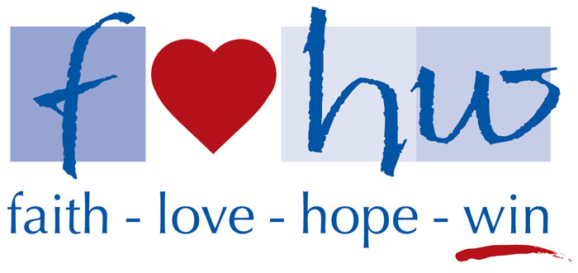
www.flhw.org
2017 Sponsor Registration Form

Company Name ________________________________________________
Description of Business __________________________________________
Address _______________________________________________________
_______________________________________________________
Contact Name __________________________________________________
Contact Telephone Number _______________________________________
Sponsorship Level (check one)
______ Double Eagle Sponsor ($5,000 minimum donation)
______ Eagle Sponsor ($2,500 minimum donation)
______ Birdie Sponsor ($1,000 minimum donation)
______ Par Sponsor ($500 minimum donation)
______ Friend of FLHW Donation (If you are unable to play and/or sponsor, but would still like to make a
donation, we appreciate your support.)

Please mail this form, along with your check payable to “FLHW”:

FLHW
15816 Ash St.
Overland Park, KS 66224

To allow time for construction of sponsorship materials, please have your contribution delivered by September 1st.
Thank you for your generous support !!
** FLHW is a 501(c)3 non-governmental, non-profit corporation, recognized by the IRS as a tax exempt public foundation. Donations are tax deductible to the extent allowed by law.

